

SDK Development Instructions
Version 1.0

Example: Device standalone application.
All the required files can be found at \\stlnetapp01\VACIFS01\public\Engineering\Software\Tools\NSIS
1. – To create an initial template follow these instructions https://www.symantec.com/connect/articles/using-nsis-build-application-installers
2. - To install drivers in 64-bit machines follow these instructions https://stackoverflow.com/questions/2464843/installing-drivers-from-nsis-installer-in-x64-system
- The current location of dpinst64.exe is \\stlnetapp01\VACIFS01\public\Engineering\Software\Distribution Subsystems\2.Drivers\DPInst\x64
- This is what the installer will execute in the ‘Driver’ folder. It automatically installs any drivers for a connected device that needs them. The command used is
- ExecWait '"$INSTDIR\Driver\dpinst64.exe" /c /q /sa /sw /PATH "$INSTDIR\Driver"'
3. - The example nsi is located in …\TIS_Development\Hardware\SDKs\Installer_Script.nsi
4. - NSIS lets you use any defined string as part of a path, multiple times. For example:
!Define PRODUCT_NAME “CSN1302”
APP_NAME “${PRODUCT_NAME}_Control.exe”
This will set APP_NAME as CSN1302_Control.exe
5. - Leaving any blank lines in a function will give errors.
6. - To sign an uninstaller we followed the idea of the next link http://nsis.sourceforge.net/Signing_an_Uninstaller. Since our installer is more complicated than the example, we split the creation of the uninstaller into its own script. The installer script will execute the first temporary installer to create our uninstaller, then sign it and add it to the installer package.
7.- To start the uninstaller if an installation is already in place we followed this example http://nsis.sourceforge.net/Auto-uninstall_old_before_installing_new with a few changes to make it more safe, and working with our scheme of separating uninstaller creation from the installer.

Instructions to sign an .inf driver file:

- You need Visual Studio 2017 installed in the computer where you are about to sign the drivers.
- Download the current Windows Driver Kit, or copy the installer from \\stlnetapp01\VACIFS01\public\Engineering\Software\Tools\Driver tools for signing
- Install WDK
- Open command prompt or Developer command prompt and navigate to the folder where the INf files are located
- Run the following command: “Inf2Cat /v /os:7_X86,7_X64,10_X86,10_X64 /driver:.”
- If successfully ran, it will create a .cat file for every INF in the folder
- Sign the .cat files with the current sign key. For Example “SignTool sign /f ...\Tools\SignKey\key.pfx /p Shenzhen /t http://timestamp.verisign.com/scripts/timestamp.dll lsk-gr08.cat”
- Now you can install the driver using dpinst or PnpUtil. For example, “dpinstx64.exe /sa /p” is the command used in the SDKs installer; this will install all the INF files from the folder where it is called.
- Remember to keep the .cat and .inf files in the same folder during installation for this to work.

Instructions for creating a SDK Release:

From a New Computer:

- Install NSIS and NSIS-edit from \\stlnetapp01\VACIFS01\public\Engineering\Software\Tools\NSIS
  - For the SDKs we also need an NSIS plugin named AccessControl. Located in
\\stlnetapp01\VACIFS01\public\Engineering\Software\Tools\NSIS\plugins
  - Unzip AccessControl.zip into the local NSIS installed folder (e.g. Program Files(x86)\NSIS), or copy all the contents from the zip file and merge with the NSIS root directory. The most important part is to have AccessControl.dll in the Plugins folder.
NOTE: For this version of NSIS (3.0+) we need to manually copy AccessControl.dll into NSIS\Plugins\x86-ansi and NSIS\Plugins\x86-unicode
- Make sure Visual Studio is installed for the SignTool command.

- Create a new Icon, using the template ‘SDK Icon template.svg’ on the SDK folder, you need InkScape to open this file. Modify it to match the name of the device. Export the image to a PNG using the option shown in the screen shot, select page as the export area and set the image size to 256x256. Use any converter only to convert it to a .ico file. I have been using http://icoconvert.com/ for now.
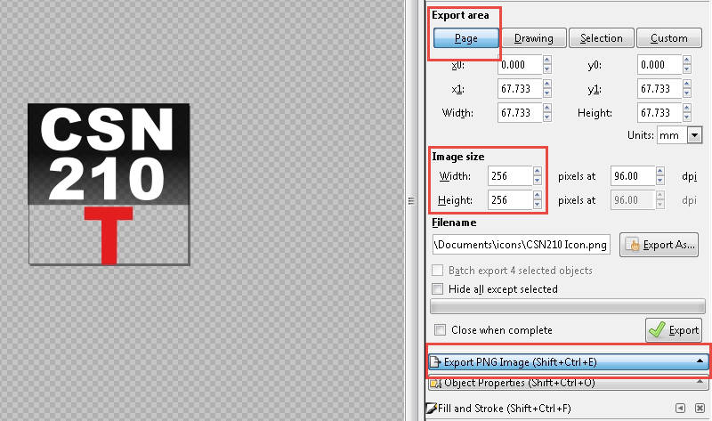
- Run "C:\Program Files (x86)\NSIS\makensis.exe" MesoScopeUI_Uninstaller_Script.nsi, and
"C:\Program Files (x86)\NSIS\makensis.exe" MesoScopeUI_Installer_Script.nsi. This will deploy an uninstaller which will be signed by the installer builder (see Device_Installer_Script.nsi line 4-7). In order to execute the temporary installer the builder will request permissions from the user. Make sure to accept for each device. Otherwise the installer builder will fail when looking for the uninstaller.

